STAT 519/619 Final Project: Temporal Bias in Deadline-Style Prediction Markets using Polymarket
Jamie Sanson, Tyrell Jaques
30071105, 30019579
Dr. Haixu Wang
April 2026
AI-Use Disclaimer: AI was used as a coding assistant while developing parts of the SQL and Python workflow and as an editing aid for early report structuring. All SQL queries were executed locally by us, and all numerical results and plots reported in this document come from the actual database outputs and model runs. We reviewed and edited any AI-assisted text for accuracy and consistency with the implemented code. Moreover, as required by the course policy, we maintained a verbatim record of the prompts used to generate text and code.

Introduction
Polymarket is a prediction market platform where contracts pay $1 if an event occurs and $0 otherwise. In most markets, the “YES” token price trades between 0 and 1 and is commonly interpreted as an implied probability. A subset of Polymarket questions are deadline-style markets, meaning they ask whether an event will occur by a specified time (for example, “Will X happen by April 30?”). These markets are useful because they naturally create a time axis: the same underlying event can be priced repeatedly when the deadline is far away and then repriced as the deadline approaches.
A natural question in deadline markets is whether the market’s implied timing dynamics change with horizon. Even if the headline YES price is stable or drifts slightly downward, the same price level implies a very different “arrival rate” when there are 30 days left versus 1 day left. That is the core motivation for analyzing term structure in implied hazard rather than only modeling the probability level. A second motivation comes from behavioral work on time preferences: standard models such as hyperbolic discounting describe systematic differences in how people weight near-term versus long-term outcomes (Frederick, Loewenstein, & O’Donoghue, 2002). In markets, horizon effects could reflect behavioral time weighting, attention and information arrival near deadlines, or purely mechanical consequences of rescaling probabilities by remaining time. The point of this project is not to attribute the mechanism definitively, but to measure whether a systematic horizon effect exists and to quantify its magnitude with uncertainty.
Existing Methods
Most empirical work on prediction markets treats the YES price as an estimate of an underlying probability and models that probability directly as a function of time-to-deadline, for example with logistic regression or other generalized linear models. An alternative framing treats resolution as an arrival-time process and converts prices into an implied hazard rate using a survival-style mapping (Wolfers & Zitzewitz, 2004). The hazard framing is useful here because it separates the level of the probability from the time remaining: the same price implies very different short-horizon dynamics when there are 30 days left versus 1 day left. Our approach combines that mapping with a hierarchical model so we can estimate a shared horizon effect while controlling for large event-to-event differences in baseline rates.
Project Approach
This project’s research question is: after accounting for event-to-event heterogeneity, does the market-implied hazard increase as the deadline approaches, and how large is that effect on the hazard scale? As a motivating descriptive check, we first compute implied hazards at three reference horizons (about 30 days, 7 days, and 1 day before the deadline). Figure 1 shows that the implied hazard increases materially close to the deadline when summarized on the log scale. This motivates the hierarchical Bayesian model that follows, which estimates the horizon effects while pooling across related markets.
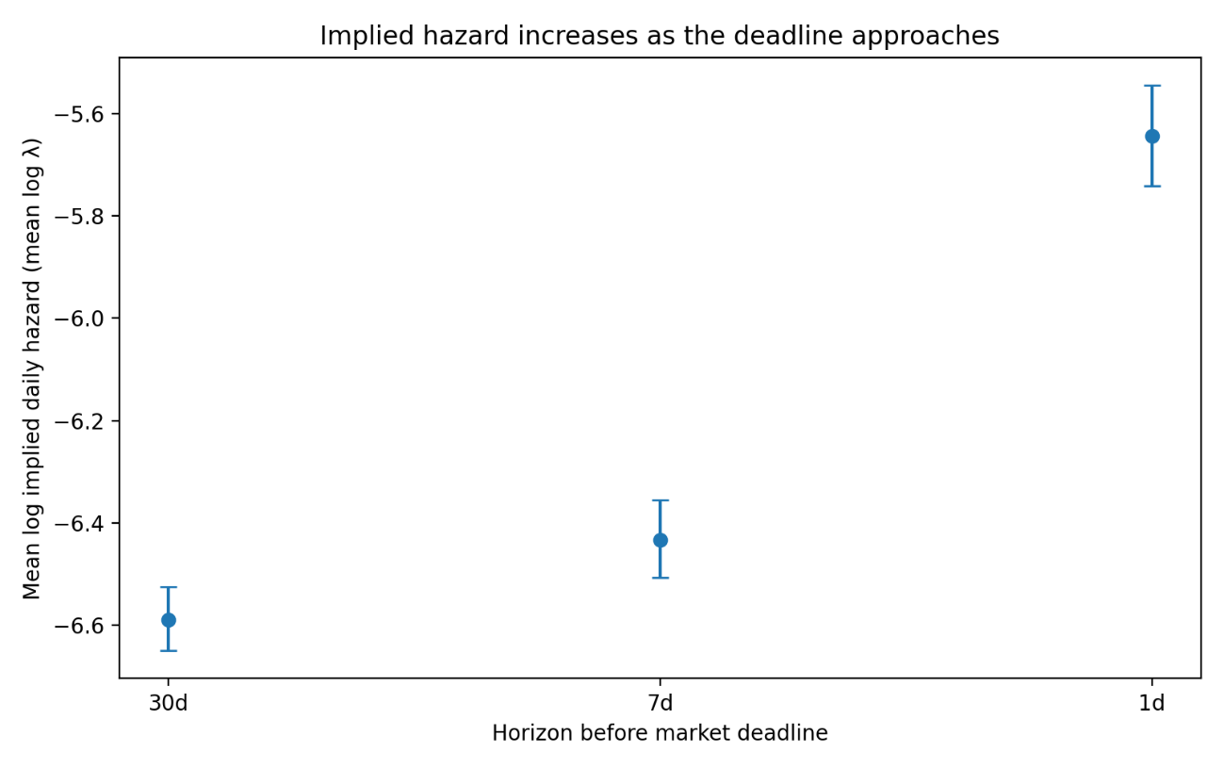
Figure 1. Mean log implied daily hazard (log λ) by horizon (30d, 7d, 1d). Points are sample means across markets in the modeling sample; error bars are 95% confidence intervals for the mean (normal approximation). The increase at 1 day is visually large relative to 30 days.
Data and Preprocessing
We worked from a local SQLite database constructed from Polymarket’s raw event exports. The database contains an events table and a markets table; market-level information was originally nested in events.markets as a JSON and was flattened into a relational markets table during preprocessing. After flattening, the full markets table contains 523,699 market objects.
We then filtered to deadline-style markets using a text-based heuristic to the market question strings. The filter searches for phrases that usually signal deadlines (e.g., “by”, “before”, “until” , “no later than”, etc.), and it explicitly excluded common sports-related false positives (e.g., “win by more than”, “by at least”, etc.). This filtering step was iteratively refined through manual inspection of roughly 2,000 sampled markets and produced 12,030 markets that plausibly represent deadline-style questions.
Price data is found in price_history, keyed by token_id. Each market has multiple outcome tokens; for our main analysis we restrict to the “YES” outcome and join on its token_id. We used a view (bets_for_timing_view) that consolidates the timing-market set and exposes the YES token_id in a way that is easy to join against price_history. We then computed the time-to-deadline in days for each price observation, which produced a long table with one row per market-price observation.
Moreover, it should be noted that not every market has dense pricing near all three horizons. We therefore distinguished between (i) the snapshot table, which records the nearest available observation to each horizon for markets with sufficient coverage, and (ii) the stricter modeling sample, which enforces that the chosen snapshots are actually close to their intended horizons. In our current run, the snapshot table contains 6,724 markets with non-missing values at all three horizons. For the Bayesian model, we enforced a “horizon purity” filter so that the 30-day snapshot is within 7 days of 30, and the 7-day and 1-day snapshots are each within 2 days of their targets. Doing so yielded 2,028 markets in the modeling sample (6,084 horizon observations)
Finally, we computed implied event-arrival rates from these prices. Under a constant hazard model with daily rate λ, the probability that an event occurs by time t (in days) is $P(t)=1 - exp(-λt)$. Solving for λ in terms of an observed probability p at horizon t gives us $λ = -\frac{log(1 - p)}{t}$. We used the YES token price as p and the time-to-deadline (in days) as t to compute an implied daily hazard at each horizon snapshot. Thus, for each market our final analysis table contains (i) the three snapshot prices, (ii) three implied rates, (iii) their log transforms, and (iv) the between-horizon deltas used in modeling. In our current run, the wide table contains 6,724 markets with sufficient data coverage to compute the horizon quantities. All SQL used to build our tables is recorded verbatim in analysis_pipeline.sql and was executed in Beekeeper Studio’s SQLite GUI (Beekeeper Studio, n.d). The final exported analysis table we used for modeling is timing_model_analysis_bft.csv.
Model specification
The key modeling move is to work on the implied hazard scale rather than directly on price levels. Price is a probability-like level. Hazard is a timing rate. For the same p, the implied λ is much larger when t is small than when t is large, which makes hazard a natural object for studying horizon effects.
For market i and horizon $h ϵ \{30, 7, 1\},$ we let $p_{\{i,h\}}$be the YES price observed at the selected snapshot, and let $t_{\{i,h\}}$ be the days remaining to the deadline at that timestamp. We then compute $λ_{\{i,h\}}= - \frac{log(1 - p_{\{i,h\}})}{t_{\{i,h\}}}$ , and define the modeled response as: $y_{\{i,h\}}= log(λ_{\{i,h\}})$. By working on the log-rate scale, horizon effects become interpretable as multiplicative changes in λ.
Moreover, markets differ dramatically in baseline likelihood because they refer to different underlying events. If we ignore that heterogeneity, we risk confusing event-specific base rates with horizon effects. To address this, we use a hierarchical model with event-level pooling. Letting g(i) be the event group for market i (using event_slug as the grouping label), our model is:
$$y_{i,h} \sim Normal(μ + u_{\{g(i)\}}+ δ_{h} , σ)$$
Here, $μ$ is the global intercept (baseline log-rate at the reference horizon), $μ_{\{g(i)\}}$is an event-level random intercept for the group $g(i)$ associated with market i, and σ is residual noise capturing market-specific variation not explained by horizon or grouping. $δ_{7d}$ is the expected change in log λ at roughly 7 days relative to 30 days, holding event baseline fixed, and $δ_{1d}$, is the analogous change at roughly 1 day versus 30 days. On the hazard scale, $exp(δ_{1d})$ is the multiplicative factor by which implied daily hazard increases at 1 day compared to 30 days. This model is effective at answering our research question because if the market-implied rate is stable across horizons for a fixed event, then $δ_{7d}$ and $δ_{1d}$ should be near zero. Moreover, if there is a systematic deadline effect, then $δ_{7d}$ and $δ_{1d}$ should differ from zero (typically positive if implied rates rise as deadlines approach).
Priors and hyperpriors
We use weakly informative priors that regularize the model on the log-hazard scale while leaving the sign and magnitude of the horizon effects to be learned from the data. The key design choice here is that $δ_{7d}$ and $δ_{1d}$are not given extremely wide priors; if they were, the posterior could be dominated by rare extreme markets, and the model would become unstable.
Global Intercept
$$μ\sim Normal\left(-5, 2\right)$$This prior centers log hazard around values consistent with the bulk of observed implied hazards while still allowing several orders of magnitude variation.
Horizon Effects with a Shared Scale Hyperprior
$$σ_{δ} \sim HalfNormal\left(1\right) \\ δ_{7d} \sim Normal(0, σ_{δ}) \\ δ_{1d} \sim Normal(0, σ_{δ})$$
This structure encodes that, a priori, we do not assume systematic horizon effects, but we allow effects of practical size. On the log scale, a coefficient of 1 corresponds to a hazard multiplier of $exp(1) ≈ 2.7$, which is large but not absurd for short-horizon dynamics.
Event-level Pooling
$$μ_{g}\sim Normal\left(0,σ_{g}\right) \\ σ_{g}\sim HalfNormal\left(1\right)$$
Here, $σ_{g}$controls how much event-level log-rates vary across event groups. If events are truly very different, $σ_{g}$ will be large, and if they are similar then $σ_{g}$will shrink and we effectively pool more.
Residual Scale
$$σ \sim HalfNormal\left(1\right)$$This prior regularizes the residual scale. If the data is noisier than this scale suggests, then σ will move upward. The HalfNormal prior simply discourages massive residual variance unless it is clearly needed.
Posterior inference (NUTS + ADVI)
We performed posterior inference using two distinct methods. First, we fit the model using ADVI (Automatic Differentiation Variational Inference), which approximates the posterior with a parameterized distribution and optimizes an evidence lower bound (ELBO) objective. We used ADVI because it is fast on the full dataset and gives us an immediate estimate of $δ_{7d}$ and $δ_{1d}$ with uncertainty (Kucukelbir et al., 2017; Abril-Pla et al., 2023).
Next, we ran MCMC using NUTS (the No-U-Turn Sampler), a Hamiltonian Monte Carlo method that adaptively chooses trajectory lengths (Hoffman & Gelman, 2014). Due to local computational constraints, we ran a “quick” NUTS configuration (1 chain, 100 tuning iterations, 100 posterior draws) on a random subsample of 2,500 horizon observations. Thus, we report NUTS-based posterior summaries as a second inference method (MCMC) and compare them to the variational results.
Both ADVI and NUTS runs are stored as an ArviZ InferenceData object in NetCDF format (lambda_model_fixed_advi.nc and lambda_model_fixed_nuts_quick.nc), allowing for the same diagnostic and plotting code to be applied to both. This is important for reproducibility, and it also makes it straightforward to rerun NUTS at higher fidelity if compute time allows.
Model checking
Diagnostics and Convergence
For ADVI, we verified that the ELBO stabilizes and that posterior summaries are not obviously pathological (for example, implausibly huge uncertainty in δ with no data explanation). For NUTS, we inspected trace plots for $δ_{7d }$ and $δ_{1d}$ and confirmed that the sampler reports zero divergences under the “quick” run. Because only one chain was run, R-hat was not available and full convergence claims are limited. With only 100 post-warmup draws, effective sample sizes for δ parameters are modest, on the order of ~10² (ArviZ bulk ESS), so NUTS uncertainty estimates here should be interpreted as approximate. As such, we treated this NUTS run as a validation of the ADVI result rather than as a final word on convergence.
Prior Predictive Checking
We simulated log hazards from the prior predictive distribution and compared them to the observed distribution of log implied hazards in the modeling sample. Figure 2 shows that the prior predictive mass overlaps the observed distribution and is not wildly miss-scaled. This supports the claim that the priors are weakly informative rather than contradictory to the data.
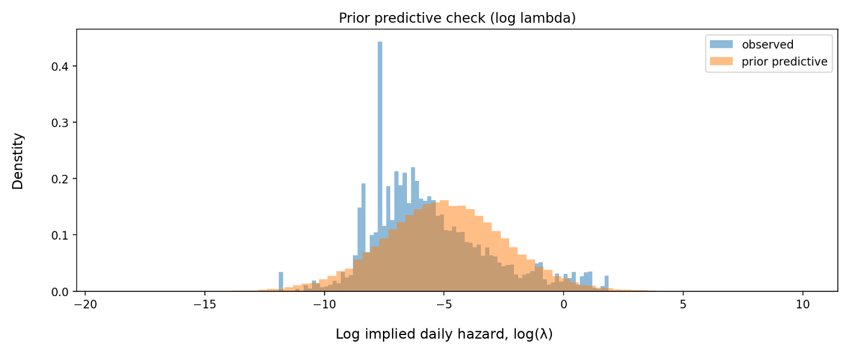
Figure 2. Prior predictive check on the log hazard scale. The prior predictive distribution overlaps the observed log implied hazards, indicating priors are on a reasonable scale.
Posterior Predictive Checking
We generated posterior predictive draws from both the ADVI fit and the NUTS “quick” fit and compared them to the observed distribution of log implied hazards. Figure 3 shows that the posterior predictive distributions match the central mass of the observed data well but understates the extreme right tail (very large hazards). A quick quantile summary makes this clear: the observed 95th and 99th percentiles are much larger (less negative) than the posterior predictive 95th and 99th percentiles. This suggests the Normal likelihood may be too light-tailed for the extremes, or that a small subset of markets behaves differently (e.g., microstructure noise, late-stage information shocks, or edge cases where prices approach 1 etc.).
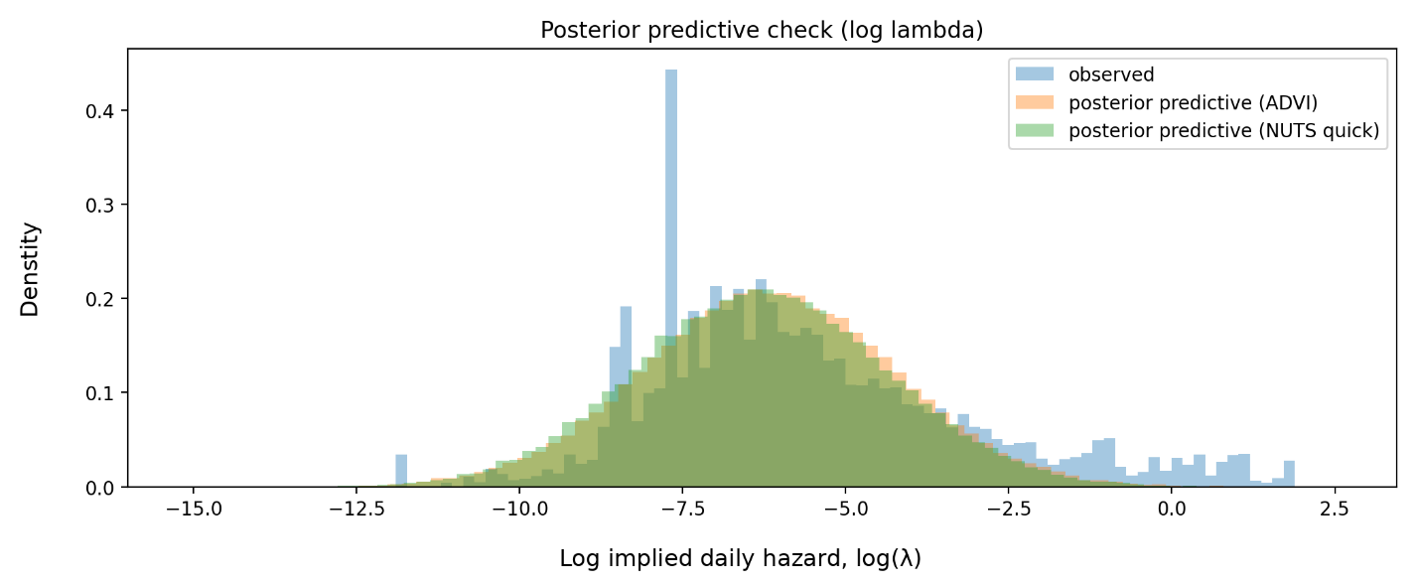
Figure 3. Posterior predictive check on the log hazard scale. Both ADVI and NUTS quick reproduce the bulk of the distribution but miss the extreme right tail.
Prior Sensitivity
We re-ran the NUTS “quick” analysis under a tighter prior on the horizon-effect scale ($σ_{δ} \sim HalfNormal(0.5)$ instead of $HalfNormal(1)$). The estimated $δ_{1d}$ remained strongly positive and $δ_{7d }$remained small with an interval that overlaps 0. This indicates that the main conclusion is not a fragile artifact of the default prior scale.
Results
Descriptive Term Structure
Figure 1 already shows that implied hazards increase as the deadline approaches when summarized on the log scale. In the modeling sample, the mean log implied hazard rises from about −6.59 at 30 days to −6.43 at 7 days and then to −5.64 at 1 day. The increase is concentrated very close to the deadline, consistent with the idea that the “1-day regime” is meaningfully different from the “30-day regime” in implied timing dynamics.
Posterior Estimates of Horizon Effects
Table 1 summarizes the posterior for $δ_{7d }$and $δ_{1d}$ under both of our inference methods. The key quantity is $exp(δ)$, which is the hazard multiplier relative to the 30-day baseline.
Inference method | Parameter | Mean δ (log) | 94% HDI for δ (log) | exp(mean δ) | 94% HDI for exp(δ)
ADVI | δ_7d | 0.072 | [-0.119, 0.251] | 1.075 | [0.888, 1.285]
ADVI | δ_1d | 0.848 | [0.689, 1.024] | 2.335 | [1.992, 2.784]
NUTS (quick) | δ_7d | 0.109 | [-0.030, 0.243] | 1.115 | [0.970, 1.275]
NUTS (quick) | δ_1d | 0.867 | [0.675, 0.989] | 2.380 | [1.964, 2.689]
Table 1. Posterior horizon effects on the log hazard scale (δ) and implied hazard multipliers exp(δ), relative to the 30-day baseline. Intervals are 94% HDIs (3% to 97%).
Our ADVI and NUTS analyses agree on the main conclusion: the 1-day horizon effect $δ_{1d}$ is strongly positive, with a hazard multiplier around 2.3 to 2.4. That is, after controlling for event-level baseline differences via partial pooling, the market-implied daily hazard at around 1 day to deadline is roughly 2.3 to 2.4 times the implied hazard at around 30 days to deadline. The 7-day effect $δ_{7d }$ however, is smaller and more uncertain. Its interval overlaps 0 in both of our inference methods, which suggests that most of the systematic increase occurs very close to the deadline. Interestingly, this pattern is not driven by prices increasing on average. The mean YES price declines slightly from about 0.302 at around 30 days to about 0.283 at around 1 day, and the median price declines substantially. This matters because it rules out the simplest story that “rates rise because probabilities rise”. Instead, it highlights why the rate transform is useful: for small p, λ behaves roughly like $\frac{p}{t}$, so even modest probabilities at very short horizons can imply large daily hazard rates.
Discussion
Our results indicate a clear term structure in Polymarket deadline markets when prices are translated into implied hazards. Figure 1 shows this directly on the log hazard scale, and the hierarchical Bayesian model confirms it after accounting for large event-to-event heterogeneity. The strongest and most robust effect is at the 1-day horizon.
There are at least two plausible mechanisms. One is an information and attention story: as a deadline approaches, traders focus on the market, relevant news arrives, and updating accelerates. Another is a mechanical scaling story: because λ depends roughly on $\frac{p}{t}$ for small p, shrinking t can raise implied daily hazard even if p stays flat or declines modestly. Our analysis is primarily descriptive in the sense that we estimate the effect and quantify uncertainty, but we do not isolate causality.
Model limitations are visible in the posterior predictive checks. Both ADVI and NUTS quick understate the extreme right tail of log hazards. This likely reflects a mismatch between a light-tailed Normal likelihood and occasional extreme market dynamics. A straightforward extension would replace the Normal likelihood with a Student-t likelihood, or include a mixture component for outlier markets, or allow σ to vary with liquidity proxies. These extensions would be valuable if the goal were a better generative model of the full distribution, but they are not required to support the headline conclusion about $δ_{1d}$, which is stable across inference methods and prior sensitivity checks.
Next, the NUTS results here are computationally constrained. We used a quick configuration and a single chain, so the NUTS run is best interpreted as a qualitative validation of the ADVI inference rather than a high-precision MCMC estimate. The fact that it agrees closely with ADVI on $δ_{1d}$strengthens confidence that the variational approximation is not producing a sign error or a wildly biased effect estimate.
Furthermore, there are clear extensions that we did not fully pursue here but that follow naturally from the proposal. First, event groupings can be enriched beyond event_slug, for example using extracted actor-action-subject factors, which would allow partial pooling across semantically related events that are not identical slugs. Second, liquidity and trading volume can be added as covariates or as a noise model component, since thin markets can show large price jumps that do not necessarily reflect information. Finally, the term-structure model can be connected to decision analysis by comparing posterior-implied beliefs to contemporaneous market prices and evaluating simple betting strategies under uncertainty.
Conclusion
Polymarket deadline-style markets exhibit a strong horizon effect when interpreted through implied event-arrival hazards. After pooling across events with a hierarchical model, the implied daily hazard at about 1 day to deadline is estimated to be roughly 2.3 to 2.4 times larger than the implied hazard at about 30 days to deadline. This conclusion is consistent across ADVI and a quick NUTS run and is robust to a tighter prior on the horizon-effect scale. The 7-day effect is modest and remains uncertain at the current level of precision.
Reproducibility and Code
All processing and analysis steps are reproducible from the project repository. The SQLite database is not committed to Git due to size, but the analysis assumes polymarket.db is present locally with the expected schema. The SQL pipeline used to construct the long join and the wide snapshot table is recorded in analysis_pipeline.sql. The final analysis table is exported as timing_model_analysis_bft.csv, which decouples model fitting from the database tooling and makes it easy to rerun inference without a GUI. All queries were executed in Beekeeper Studio.
Model fitting, inferences, and plotting were performed in Python using PyMC, with outputs and diagnostics handled via ArviZ. The main scripts are: run_lambda_model_fixed.py (ADVI fit and saved InferenceData), run_fixed_nuts_quick.py and run_fixed_nuts_quick_sensitivity.py (MCMC), summarize_fixed.py (posterior summaries), plot_diagnostics.py (posterior density and trace plots), and ppc_quick.py (prior and posterior predictive checks). Running these scripts after rebuilding the analysis table reproduces the figures and numerical results reported above.

References
Abril-Pla, O., Andreani, V., Carroll, C., Dong, L., Fonnesbeck, C. J., Kochurov, M., Kumar, R., Lao, J., Luhmann, C. C., Martin, O. A., Osthege, M., Vieira, R., Wiecki, T., & Zinkov, R. (2023). PyMC: A modern and comprehensive probabilistic programming framework in Python. PeerJ Computer Science, 9, e1516.
Beekeeper Studio. (n.d.). Beekeeper Studio: SQL editor and database manager [Computer Software]. (Used for SQLite query execution during the project).
Frederick, S., Loewenstein, G., & O’Donoghue, T. (2002). Time discounting and time preference: A critical review. Journal of Economic Literature, 40(2), 351–401.
Hoffman, M. D., & Gelman, A. (2014). The No-U-Turn sampler: Adaptively setting path lengths in Hamiltonian Monte Carlo. Journal of Machine Learning Research, 15, 1593–1623.
Kucukelbir, A., Tran, D., Ranganath, R., Gelman, A., & Blei, D. M. (2017). Automatic differentiation variational inference. Journal of Machine Learning Research, 18(14), 1–45.
Kumar, R., Carroll, C., Hartikainen, A., & Martin, O. (2019). ArviZ a unified library for exploratory analysis of Bayesian models in Python. Journal of Open Source Software, 4(33), 1143.
Polymarket. (n.d.). Polymarket platform data exports used in this project (downloaded during the project period).
Wolfers, J., & Zitzewitz, E. (2004). Prediction markets. Journal of Economic Perspectives, 18(2), 107–126.

